CAK 101 Course Syllabus
CAK 101 – Intro to Cake Baking
Section 001
Fall 2018
3 Credit Hours
Course Description
This course will provide an introduction to baking and decorating cakes. A variety of cakes will be explored, including chocolate, vanilla, lemon, red velvet, and many other flavors. Students will learn what makes cake delicious and how to create the most delicious cakes.
Learning Outcomes
By the end of this course, students will be able to:
- Create cake mix of a variety of flavors from scratch
- Describe the delicious flavors in any particular cake
- Bake superior cakes to be enjoyed by family and friends
Course Structure
Lectures will be given in a traditional classroom, where the instructor will share photographs and samples of exemplary cakes to be studied. Lab will take place within a large kitchen with many stoves and countertops, where the students will perform experiments in cake baking and decorating.
Course Policies
Use of electronics during lecture and lab is encouraged, but only if you are using your technology for course-related purposes, such as viewing images of cakes. Please refrain from eating or discussing carrot cake during class. It is an abomination among cakes.
Instructors
Kay Kisgood, Ph.D. - Instructor
Office Location: 100 Cakeshop Hall
Office Hours: Mondays: 2:00 p.m. - 4:00 p.m. Fridays: 2:00 p.m. - 4:00 p.m.
Course Meetings
Lecture
Days: Tuesday
Time: 1:30pm - 3:20pm
Campus: Main
Location: 1101 Cakeshop Hall
This meeting is required.
Lab
Days: Friday
Time: 11:20am - 1:10pm
Campus: Main
Location: 1104 Cakeshop Hall
This meeting is required.
Course Materials
Textbooks
Cake Decorating for Dummies - Joe LoCicero
Edition: 1st
ISBN: 9780470099117
Cost: $5.99 (used at campus bookstore)
This textbook is required.
Expenses
Museum of Cake admission fee - $1.00
This expense is optional.
Materials
Cake pan - $2.50
This material is required.
Requisites and Restrictions
There are no pre-requisites, co-requisites, or restrictions.
Transportation
You may choose to attend the optional Museum of Cake field trip at the end of the semester. If you choose to attend, you will provide your own transportation.
Safety & Risk Assumptions
Students will be exposed to hot stoves during lab. Students are responsible for practicing safety techniques, which we will go over during the first lecture and lab.
Grading
Grade Components
Two labs will be worth 90% of your grade. Attendance to lab and lecture will be worth 10% of your grade.
Requirements for Credit-Only (S/U) Grading
In order to receive a grade of S, students are required to take all exams and quizzes, complete all assignments, and earn a grade of C- or better. Conversion from letter grading to credit only (S/U) grading is subject to university deadlines. Refer to the Registration and Records calendar for deadlines related to grading. For more details refer to http://policies.ncsu.edu/regulation/reg-02-20-15.
Requirements for Auditors (AU)
Click this to see policies.
Letter Grades
This course uses standard NCSU letter grading:
97 | ≤ | A+ | ≤ | 100
93 | ≤ | A | < | 97
90 | ≤ | A- | < | 93
87 | ≤ | B+ | < | 90
83 | ≤ | B | < | 87
80 | ≤ | B- | < | 83
77 | ≤ | C+ | < | 80
73 | ≤ | C | < | 77
70 | ≤ | C- | < | 73
67 | ≤ | D+ | < | 70
63 | ≤ | D | < | 67
60 | ≤ | D- | < | 63
0 | ≤ | F | < | 60
Attendance Policy
Attendance Policy
http://policies.ncsu.edu/regulation/reg-02-20-03
Attendance to lab and lecture will account for 10% of your grade. Lab attendance is very important because most of your graded assignments will be completed during this time. Please see.
Absences Policy
Click here
If you are absent from class due to a university excused absence, the absence will not count against your grade.
Makeup Work Policy
If you are absent from class due to a university excused absence, you may make up your work within one week (7 days) of returning to class without penalty.
Additional Excuses Policy
If you miss class to attend an event related to cake baking or decorating, you may share photos of your experience with the class to have the absence excused.
Below is a photo I took of a beautiful cake I created at the Raleigh Cake Convention in 2017:
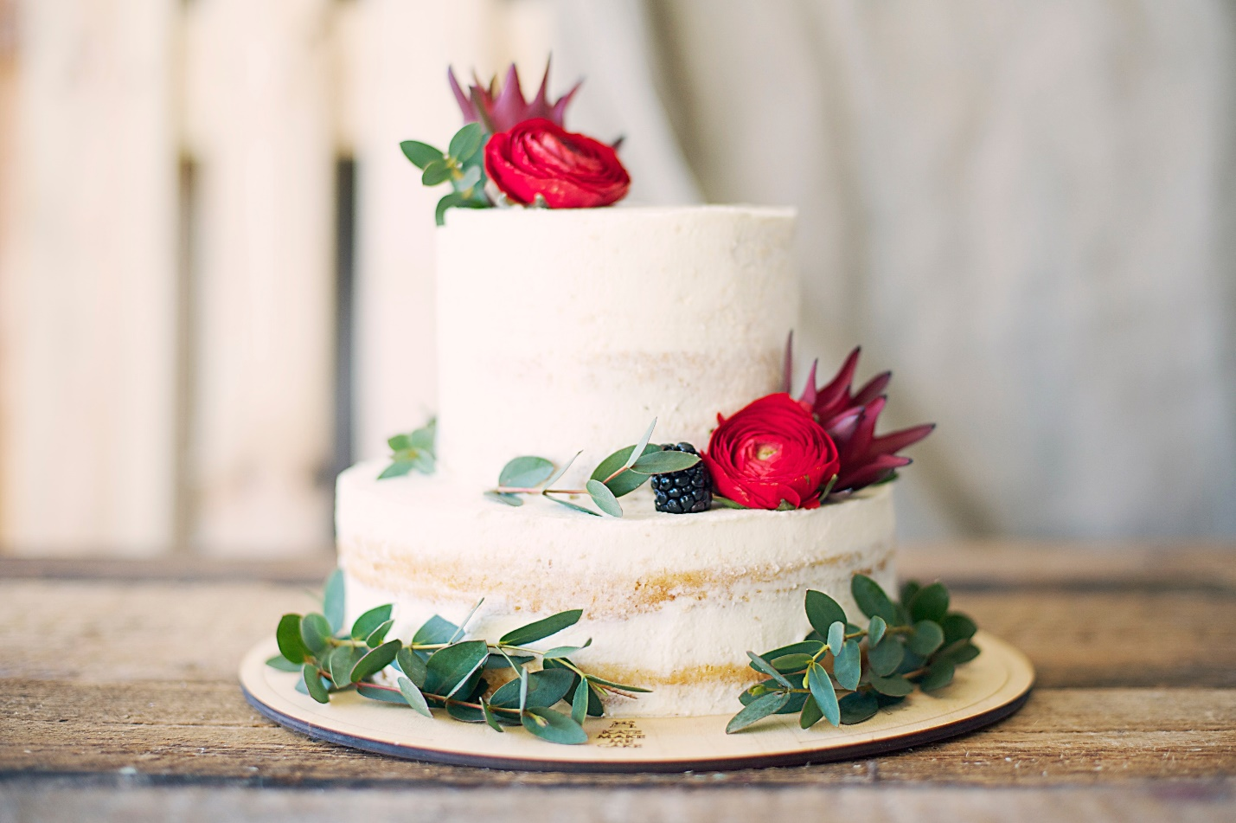
Academic Integrity
Course Schedule
Tuesday, Sept. 4th – syllabus overview, introductions
Friday, Sept. 7th – elementary baking lab
Tuesday, Sept. 11th – guest lecture on icing technique
Friday, Sept. 14th – lemon cake lab
Tuesday, Sept. 18th – final exam

